**Router on a Stick inter-VLAN Routing**

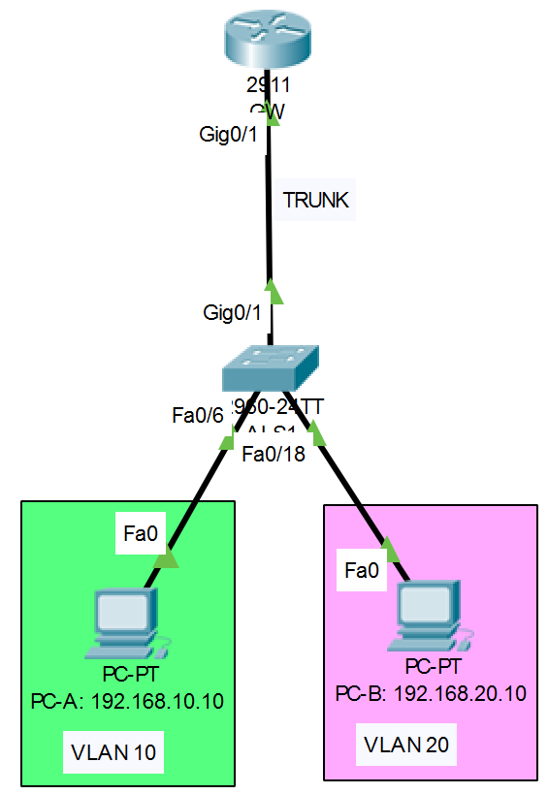

To allow the router to route between VLAN 10 and VLAN 20 using one physical interface Gi 0/1 we need to do the following configurations:

1. Router GW Gi 0/1 interface must be configured as a trunk interface with multiple IPv4 addresses as gateway for VLAN 10 and VLAN 20.
2. ALS1 switch Fa 0/6 interface must be access port in VLAN 10.
3. ALS1 switch Fa 0/18 interface must be in VLAN 20.
4. ALS1 witch Gi 0/1 interface must be trunk.

**Solution**

1. Router GW Gi 0/1 interface must be configured as a trunk interface with multiple IPv4 addresses as gateway for VLAN 10 and VLAN 20. The gateway IP addresses are configured on the sub-interfaces. Sub-interfaces are software interfaces. They physically do not exist. They allow you to configure multiple IPv4 addresses on a single physical interface. The **encapsulation** command maps a sub-interface to a specific VLAN. The sub-interface and the VLAN number need not match. You must configure the encapsulation command before you are allowed to configure the IPv4 address on the sub-interface. The **no shutdown** command is configured on the physical interface gi 0/1 and not the sub-interface.

**! GW**

**hostname GW**

**int gi 0/1**

**no shutdown**

**int gi 0/1.44**

**encapsulation dot1q 10**

**ip address 192.168.10.1 255.255.255.0**

**int gi 0/1.55**

**encapsulation dot1q 20**

**ip address 192.168.20.1 255.255.255.0**

1. ALS1 switch Fa 0/6 interface must be access port in VLAN 10.
2. ALS1 switch Fa 0/18 interface must be in VLAN 20.
3. ALS1 witch Gi 0/1 interface must be trunk.

Note that when you map a switchport to a VLAN that does not exist, then the switch will create this VLAN.

**! ALS1**

**int fa 0/6**

**switchport mode access**

**switchport access vlan 10**

**int fa 0/18**

**switchport mode access**

**switchport access vlan 20**

**int gi 0/1**

**switchport mode trunk**

**Exercise**

Extend the network to include the below VLANs 30 and 40.

